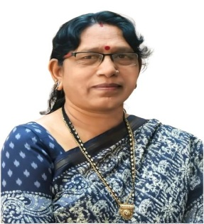**BIO DATA**

|  |  |  |
| --- | --- | --- |
| 1. | Name | Dr. Malti (Dewdas) Tiwari |
| 2. | Designation | Assistant Professor Political Science |
| 3. | Nationality | Hindi |
| 4. | Date of Birth | 15/07/1967 |
| 5. | Fathers Name | Late. Kashiram Dewdas |
| 6. | Class (ST/SC/OBC/GEN) | SC |
| 7. | Gender (M/F) | F |
| 8. | Appointment Date | 14/10/1993 |
| 9. | Type of Appointment | Regular |
| 10. | Pay Scale | 210800 |
| 11. | Address (Residence) | Aadarsh Nagar Ward No 29 Bagbahara Road Mahasamund (C.G.)  Pin Code 493445 |
| 12. | Address (Correspondence) | Aadarsh Nagar Ward No 29 Bagbahara Road Mahasamund (C.G.)  Pin Code 493445 |
| 13. | Mobile Number | 9424240367 |
| 14. | Teaching Experience | 31 Year |
| 15. | Qualification |  |
|  | 1. P.G. | Political Science |
|  | 2. M.Phill./Ph.D./D.Litt. | Ph.D. |
|  | 3. Refresher/Orientation | Refresher (04) + Orientation (01) = 05 |
|  | 4. Research Publication | 28 |
|  | 5. Published Books | 05 |
|  | 6. Certificates | 35 |
|  | 7. Research Project | Nil |
|  | 8. Award | 01 (NSS National IG Award) |
|  | 9. Workshop/Seminar | Workshop (04) + Seminar (65) = 69 |
|  | 10. Additional Information | Registered 04, Awarded 04 |

**:: Declaration ::**

I do hereby declare that all the above information given by me is true to the best of my knowledge.

Signature