BIO DATA
1 | NAME | Dr. Ajay Kumar Dewangan 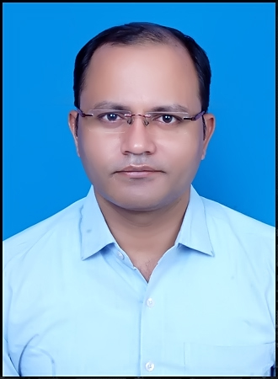
2 | DESIGNATION | ASSISTANT PROFESSOR COMPUTER APPLICATION
3 | NATIONALITY | INDAIN
4 | DATE OF BIRTH | 12/12/1982
5 | FATHER’S NAME | SRI BISHE LAL DEWANGAN
6 | CLASS (ST/SC/GEN/OBC) | OBC
7 | GENDER,(M/F) | MALE
8 | APPOINTMENT DATE | 22/01//2022
9 | TYPE OF APPOINTMENT | PSC SELECTED
10 | PAY SCALE | 57700-6000-182400
11 | ADDRESS (RESIDENCE) | SR. MIG-62 HOUSING BOARD COLONY,MACHEWA, MAHASAMUND
12 | ADDRESS (CORRESPONDENCE) | GOVT M.V.P.G COLLEGE MAHASAMUND
13 | MOBILE NUMBER | 7000800024,9826160582
14 | E-MAIL ID | Ajaydewangan1212@gmail.com
15 | TEACHING EXPERIENCE | 16 YEARS HIGHER EDUCATION CONTINUE
16 | QUALIFICATION | MCA,M.PHIL (CS), UGC-NET,PH.D(CS)
 | 1.PG | MCA-2008
 | 2.REFRESHER/ORIENTATION | ORIENTATION 02
 | 3.WORKSHOP/SEMINAAR | 13
 | 4.RESEARCH PUBLICATION | 04
 | 5.PUBLISHED BOOKS | NIL
 | 6.CERTIFICATES | 13
 | 7.RESEARCH PROJECT | NIL
 | 8.AWARD | NIL
 | 9.ADDITIONAL INFORMATION | NIL

Declaration-
I do hereby declare that all the above information given by me is true to the best fo my knowledge .
Date -05/11/202

Signature
Dr. Ajay Kumar Dewangan
(Assistant Professor computer Application)

