**Bio-Data**

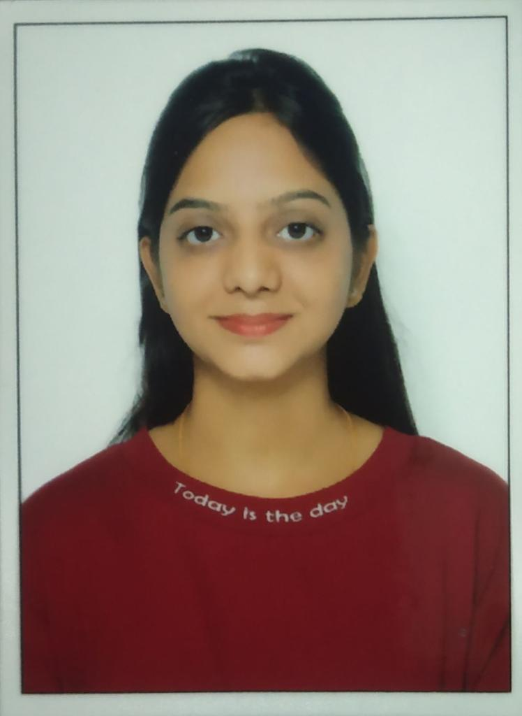

|  |  |  |
| --- | --- | --- |
| **1** | **Name** | **Namrata Tamboli** |
| **2** | **Designation** | **Guest Lecturer (Chemistry)** |
| **3** | **Nationality** | **Indian** |
| **4** | **Date Of Birth** | **31-12-1993** |
| **5** | **Fathers Name** | **Devanand Tamboli** |
| **6** | **Class (ST/SC/OBC/GEN.)** | **OBC** |
| **7** | **Gender (M/F)** | **F** |
| **8** | **Appointment Date** | **12-03-2021** |
| **9** | **Type Of Appointment** | **-** |
| **10** | **Pay Scale** | **-** |
| **11** | **Address(Residence)** | **Rajendra Book Depot, Takhatpur, Bilaspur** |
| **12** | **Address(Correspondence)** | **Kaushik Colony, Mahasamund** |
| **13** | **Mobile Number** | **9589100887** |
| **14** | **Email-Id** | **namratatamboli93@gmail.com** |
| **15** | **Teaching Experience** | **3 Years** |
| **16** | **Qualification** |  |
| **1.P.G.** | **M.Sc. Chemistry** |
| **2. M.Phil./Ph.D./D.Litt.** | **Ph.D. ongoing** |
| **3. Refresher/Orientation** | **Nil** |
| **4. Research Publication** | **Nil** |
| **5. Published Books** | **Nil** |
| **6. Certificates** | **Nil** |
| **7. Research Project** | **Nil** |
| **8. Award** | **Nil** |
| **9. Workshop/Seminar** | **Yes** |
| **10. Additional Information** | **SET** |

**Declaration**

**I do hereby declare that all the above information given by me is true to the best of my knowledge.**

**Date - 08/03/2025 **

**Signature**

**Name- Namrata Tamboli**

**Designation- Guest Lecturer**